**CHEMISTRY Unit 1 and 2**

**Fuels Investigation**

**Aim**

To investigate how the length of the carbon chain, within different alcohols effects the amount of energy released during combustion.

You will be provided with the following alcohols:

**ethanol, propanol, butanol and pentanol**

**Task**

Carry out an investigation to find out which of these alcohols releases the most amount of energy during combustion.

You have 1 period to carry out this investigation, and complete the investigation task sheet.

You will complete a **validation** which will be completed in one period. Your task sheet will be collected prior to the **validation**.

**Method**

1. Fill the conical flask with 100 mL of water. Clamp the flask at a suitable height so that the

spirit burner can be easily placed below.

1. Weigh the spirit burner containing the alcohol and record the mass.
2. Record the initial temperature of the water using the thermometer.
3. Place the spirit burner under the conical flask and light the wick.
4. Allow the alcohol to heat the water for 5 minutes.
5. Extinguish the flame.
6. Record the final temperature of the water.

7. Reweigh the spirit burner and work out the mass of alcohol used. Repeat for different

alcohols. Use 100 mL of new cold water each time.

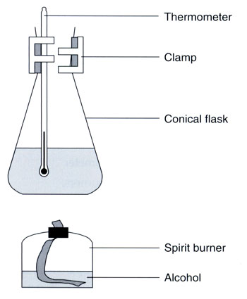

**Pre lab Questions**

1. Identify the independent variable for this experiment.

………………............................................................................................................................

..................................................................................................................................................

1. Identify the dependent variable for this experiment and what are the units.

..................................................................................................................................................

……………................................................................................................................................

1. Describe at least four variables you are going to control during your investigation.

..................................................................................................................................................

..................................................................................................................................................

..................................................................................................................................................

..................................................................................................................................................

**Results table**

|  |  |  |  |  |
| --- | --- | --- | --- | --- |
|  | **Mass of fuel at start (g)** | **Mass of fuel at end (g)** | **Temp at start (oC)** | **Temp at finish (oC)** |
| Ethanol C2H5OH |  |  |  |  |
| Propanol C3H7OH |  |  |  |  |
| Butanol C4H9OH |  |  |  |  |
| Pentanol C5H11OH |  |  |  |  |

**Processing of Results**

1. Use your results table to complete the following table.

|  |  |  |  |  |
| --- | --- | --- | --- | --- |
|  | **Mass of fuel used (g)** | **Mass of water (g)** | **Temp change (oC)** | **Energy produced (kJ)** |
| Ethanol C2H5OH |  | 100 |  |  |
| Propanol C3H7OH |  | 100 |  |  |
| Butanol C4H9OH |  | 100 |  |  |
| Pentanol C5H11OH |  | 100 |  |  |

**Energy produced = mass of water x specific heat x temperature**

**capacity of water difference**

**(specific heat capacity of water = 4.186 Joule/g°C)**

1. Write balanced equations for the four combustion reactions.

2. Calculate the moles of each fuel used and hence the enthalpy change (kJ mol-1) for each fuel.

Conclusion.